We will now look at searching for specific character strings within fields. We use the statement search to do this unsurprisingly, and it has a very simple form.



So, we can key in the word search, and we enter the field we want to search. So, in our case let's use sur name again. So, name two, and then you specify four, and then the actual search string itself. Let's say one, two, three, and a full stop.

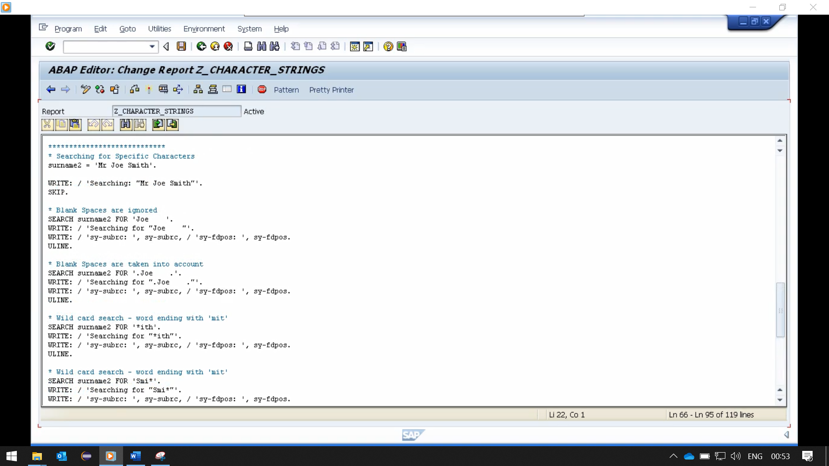

Now this type of statement is a little different to the others, in that we're not specifying a variable, to hold any result. What happens with the search statements, is two system variables are used.

The first one SY-SUBRC, which identifies whether the search was successful or not.

In the second system variable is SY-FDPOS. And if the search was successful this field is set to the position of the character string that we are searching for in surname two.

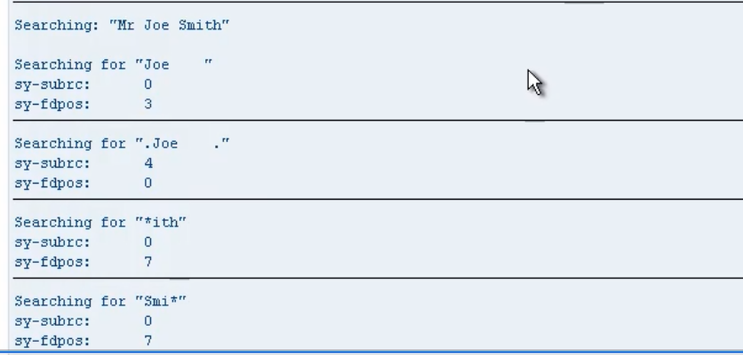

we'll look at different variations that will introduce how these system variables can be used to determine the success of the individual search.





So first off, we're using the surname2 variable as before. So, this is SEARCH surname2, for and we've got Joe with some spaces after in quotes. So, what this is saying is, we want to search for the word Joe, but the trailing spaces with the way we're using search here, are going to be ignored. And then the output would show literal string, for what we are searching for. And then, we're going to output the system variables, sy subrc and sy-fdpos. And the actual value.



this time the system will not ignore blank spaces. So, the system will search for Joe With, I think it's four spaces after the letter E. And if we look at our surname2 field, there's only one space after the letter E. So, it should return subrc equal 4, which means an unsuccessful search. And because it was unsuccessful, then the SYFD positive value will be zero.



Then the next search, this is using a wildcard. And the way we have the search defined here, it will search for any word within the string. That ends with ITH. Now because we have Smith, and it ends with ITH, it should be a successful search, and we should get the offset position, and get the pause system variable.



And the last example, it's another wild card search, but this time we're going to be searching for any word starting with Smi. And the variable we are searching does contain the word Smith. So, we should get a successful search. And again, the sy-fdpos system variable. Will be filled with the offset value relating to the position of the word.